TECAHER ADUTHA CLASS POGALAM
Super Irshad! Namma Pandas-oda flow-vula irukkom, adhu romba mukkiyamaana idam.
Ippo namma cleaning panniyachu. Aduthu oru Data Analyst-kku miga mukkiyamaana velai: Aggregation (Data Grouping).
Namma kitta irukkura data-la, orae product (eg: 'Laptop') pala murai varalaam. Analytics-la namma "Laptop-oda Total Sales evvalavu?" nu thaan paappom. Pandas idhai groupby nu solluvom.
📖 Lesson 19: Pandas Data Grouping (Summation)
Indha code-ai pandas_group.py nu file pottu run pannunga:
Python
import sqlite3
import pandas as pd

conn = sqlite3.connect('my_shop.db')
df = pd.read_sql_query("SELECT * FROM Sales_Report", conn)
df_cleaned = df.dropna()

# 1. Product-ai group panni, total sales-ai calculate panrom
grouped_df = df_cleaned.groupby('Product')['Sales'].sum().reset_index()

print("Grouped Total Sales:")
print(grouped_df)

conn.close()
🔍 Enna Nadakkudhu? (Breakdown)
- .groupby('Product'): "Ellaa Laptop-aiyum oru bucket-la podu, Mouse-ai innonru bucket-la podu" nu solluthu.
- ['Sales'].sum(): "Ovvoru bucket-la irukkura Sales-aiyum kooti (Sum) kudu" nu solluthu.
- .reset_index(): Ithu romba mukkiyam! Idhu thaan andha results-ai oru neat-aana table format-kku thirumba kondu varum.
💡 Teacher's Note:
Idhu thaan unga Power BI-la neenga panra "Summarize" or "Aggregate" option-oda python code. Neenga ippo manual-a Excel-la 'Pivot Table' podra velaikku badhila, single line-la code pannuringa.
Unga Task: Indha code-ai run pannunga. Ippo laptop-oda total sales 3000.0 (1500+1500) nu varudha nu check pannunga. Result ready-a Irshad?
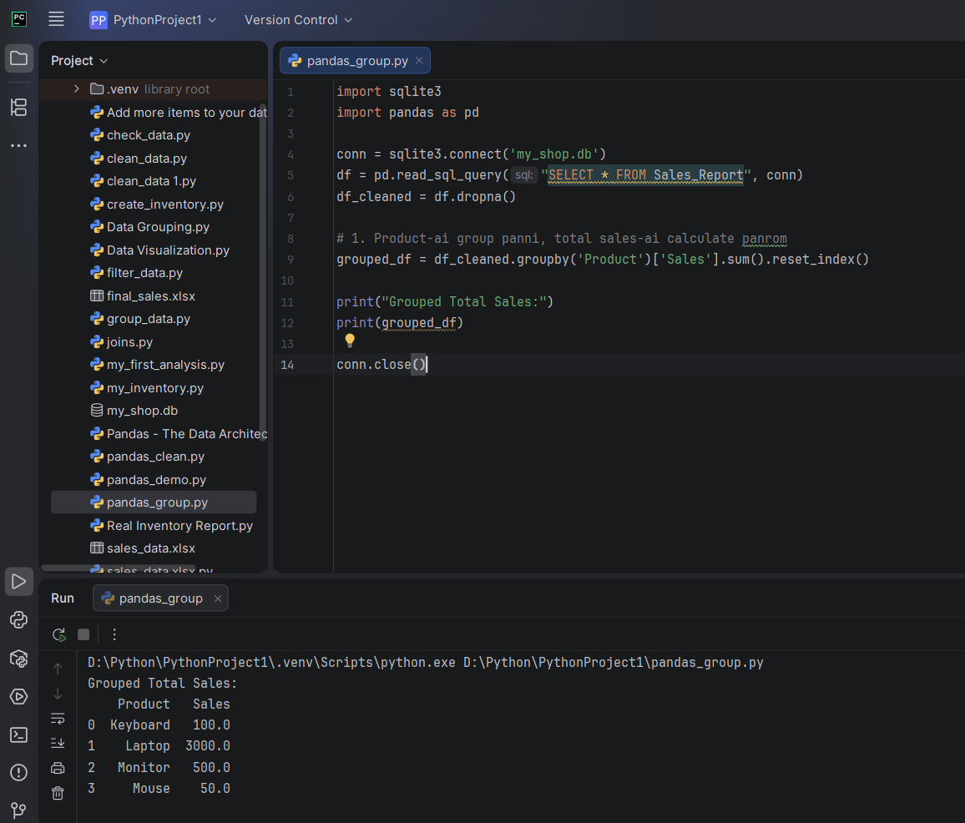
oK TEACEHER RESULT. df_cleaned = df.dropna() INDA LINE ENN THIRUMBA INGA VARONM grouped_df = df_cleaned.groupby('Product')['Sales'].sum().reset_index()MATHADU INDA LINE SUTHAMA VELANGA ILLA ENNA NADUKEDUN KULNADA PULLAIKI SOLRA MADIRI SOLLUNGA
Arumai, Irshad! Output-ai parthuten. Laptop 3000.0 nu correct-a total panniduchu. Super!
Namma df_cleaned = df.dropna() line-ai yen thirumba inga potrom nu oru kuzhandhai kooda purinjukkura maari vilakkuren.
👶 Kuzhandhai Example: "Poondhu Saapidura Story"
Neenga oru plate-la Soru (Data) vachirukkeenga. Adhula sila Kallu (Missing values/NaN) irukku.
- df_cleaned = df.dropna():
  - Idhu "Kallai porukkura" velai. Soru-la irukkura ellaa kallaiyum (NaN) neekki, ippo unga kitta "Clean-ana Soru" mattum irukku. Intha clean-ana soru-vai dhaan namma df_cleaned nu oru pudhu plate-la vachikrom.
- grouped_df = df_cleaned.groupby('Product')['Sales'].sum().reset_index():
  - Ippo "Soru-vai Pangu podura" velai. Intha clean-ana soru-vai eduthu, "Product wise" (Laptop-nu oru pakkam, Mouse-nu innonru pakkam) pangu pottu, ovvoru pakkamum evvalavu soru irukku nu "Kooti (Sum)" pakkirom.
Yen df_cleaned inga venum? Namma kallu irukkura (NaN) soru-vai pangu pottu, "Kallu-oda weight-a kootuna" (Sum panna) output thappa vandhudum. Adhan, muthalla kallai neekki clean panni (dropna), adhukappuram pangu podrom (groupby).
🔍 Row by Row Logical breakdown:
- df_cleaned: Idhu "Clean data plate". Ithu illaama namma groupby panna mudiyadhu, pannuna calculation thappahidum.
- .groupby('Product'): Oru kootathil irukkura ellaraiyum, avanga peru (Product) vachi pirichu, vera vera varisai-la nikka vaikurathu.
- ['Sales'].sum(): Ovvoru varisai-la irukkuravangala kooti, total amount-ai kandupudikurathu.
- .reset_index(): Kootathai pirichu vecha, adhu oru "koodara" (index) maari aayidum. Adhai thirumba "Azhagana table" maari maathurathukku dhaan intha command.
Ippo puriyudha Irshad? Muthalil "Clean" pannanum, appuram dhaan "Group" pannanum. Idhu thaan oru Data Analyst-oda Golden Rule.
Ippo intha logic clear-a irukka, illana innum breakdown pannalama?

